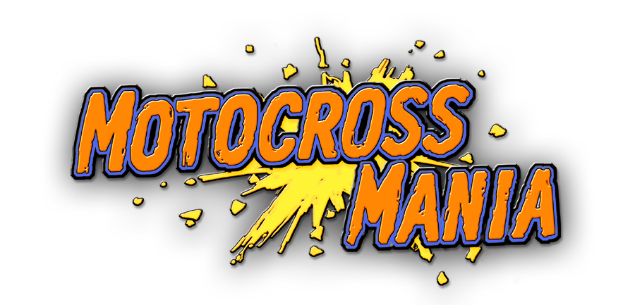
Overview:

Motocross Mania provides three styles of brutal competitive action on the toughest off-road tracks imaginable: Motocross, Supercross, and Freestyle. Players can take part in single events, multiplayer battles, competitive tournaments, or participate in time trials across the track of their choice. In practice mode, each of the tracks is a free roaming environment - find huge jumps off the beaten path! Progressing in the game unlocks different bikes, tracks, and insane aerial tricks. The bottom line here is big air and cutthroat racing! Motocorss Mania is set for release on June 15, 2001.

Features:

- The only free roaming dirt bike game for the Sony PlayStation®!
- Three types of racing: Motocross, Supercross, and Freestyle
- Fast-paced arcade gameplay over a range of vast environments
- Win championships to earn money and upgrade bike components
- A range of terrains, including dirt, mud, ice, and sand, each affecting the handling of the bike
- In Motocross mode, watch out for huge drops and narrow bridges!
- Just like in real life racing, Supercross tracks require an emphasis on rhythm and timing
- Freestyle mode requires players to perform death-defying stunts and tricks off of huge manmade jumps and platforms
- Race in single events or championship tournaments, or participate in time trials on any track
- Hidden and unlockable tracks and bike features
- Part of the Take 2 Interactive $9.99 “Got Game” Sony PlayStation® lineup



Published by: Take 2 Interactive
Developed by: Deibus

